CslaExtension Demo Application

### Description

These are the steps for creating a CslaExtension demo application. You can download the source code from <http://t4csla.codeplex.com/>

It is recomended to read CslaExtension Quick Start before.

### Setup Database

Create Northwind database using provided SQL script or use existing database. Open the script and execute it using SQL Server Management studio (for this demo we used local SQL Express instance).

### Setup Project

1. Create new VS CSharp Library project and name it **CslaExtensionDemo.Library** and click OK:

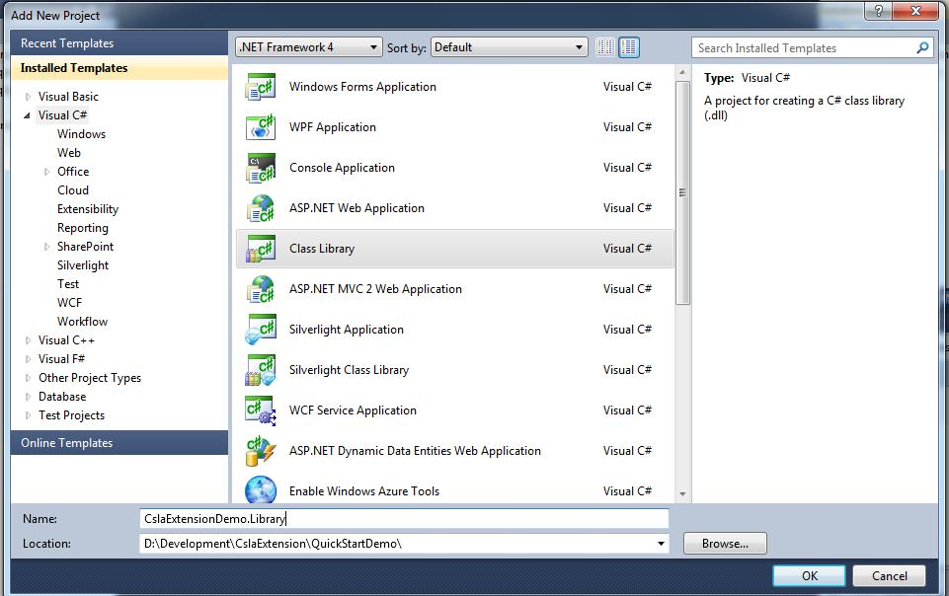

1. Delete file named Class1.cs.
2. Add new Folder to the project (right click on the project -> Add New Folder) and name it Data. Now your project should look like this:

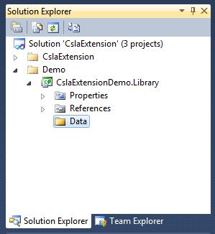

1. Add new ADO.NET Entity Framework Model (right click on the **Data folder** -> Add new item -> Data -> ADO.NET Entity Data Model) and name it **NorthwindModel.edmx:**

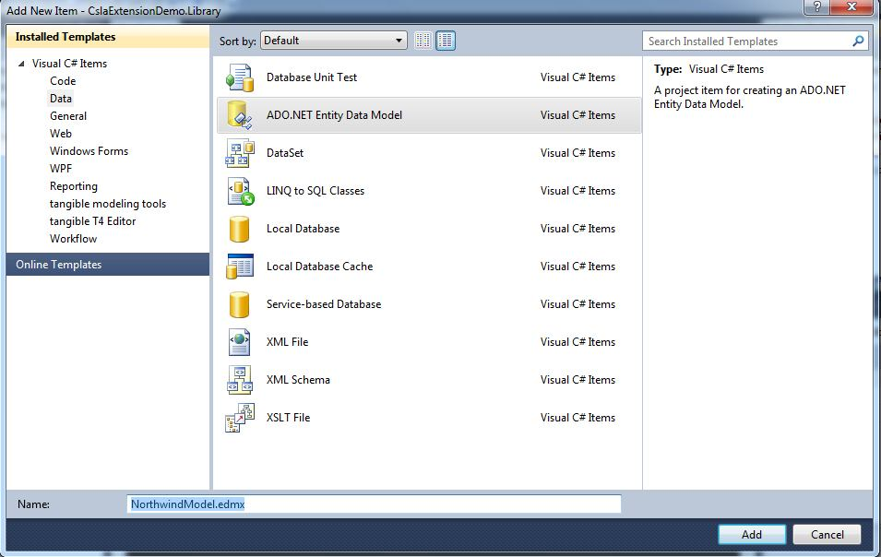

Click Add, then follow wizard steps:

* *Choose model Contents*: Generate from database
* *Choose your data connection*: Choose existing connection or create new connection pointing to the Northwind database
* *Choose your database objects*: Expand tables, select Customers, Orders, Order Details

Important BETA1: Edit Model Namespace and type in namespace in which entity objects will be created. For this demo the namespace is **CslaExtensionDemo.Library.Data**

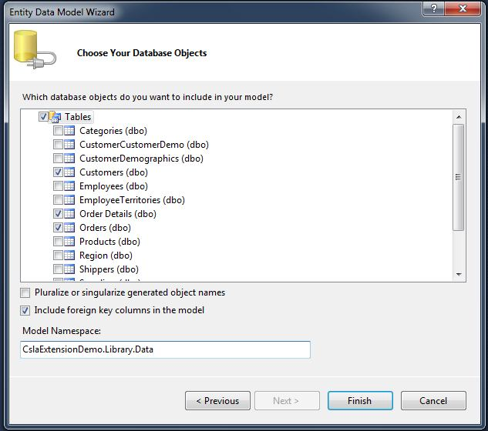

1. Click on the empty area of the EF model designer to view properties (click F4 to view properties window). Find Csla Namespace property of the EF designer and type CslaExtensionDemo.Library ( this is the namespace where CSLA classes will be generated)

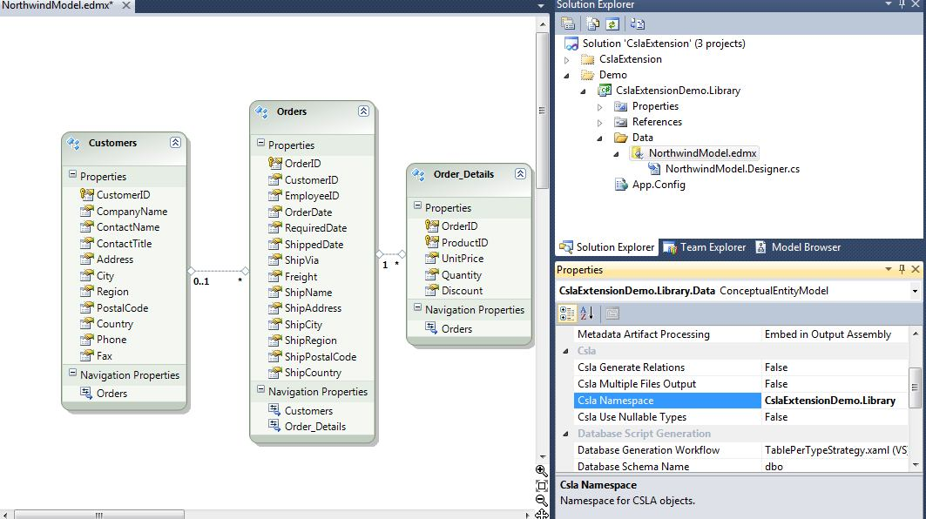

1. Right click on the empty area of the EF designer and choose : Add code generation item...

Choose CslaExtension.Template and click Add

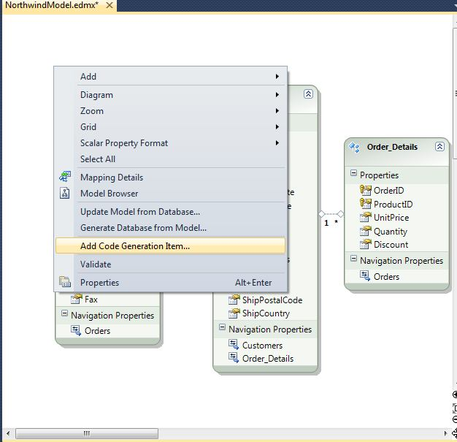

Important BETA1: you must manualy configure path to the EF edmx file. Open tt file (if not already open), find $edmxInputFile$ variable and write path to the edmx file instead. In our sample application that line should like this:

MetadataContext ctx = MetadataContext.Create(this, @"NorthwindModel.edmx");